Name: Vedika Dhende
PRN No: 22510054

High Performance Computing Lab
Practical No. 10

Title of practical: Understanding concepts of CUDA Programming

Problem Statement 1:
Execute the following program and check the properties of your GPGPU.

#include <stdio.h>
#include <stdlib.h>
int main()
{
int deviceCount;
cudaGetDeviceCount(&deviceCount);
if (deviceCount == 0)
{
printf("There is no device supporting CUDA\n");
}
int dev;
for (dev = 0; dev < deviceCount; ++dev)
{
cudaDeviceProp deviceProp;
cudaGetDeviceProperties(&deviceProp, dev);
if (dev == 0)
{
if (deviceProp.major < 1)
{
printf("There is no device supporting CUDA.\n");
}
else if (deviceCount == 1)
{
printf("There is 1 device supporting CUDA\n");
}
else
{
printf("There are %d devices supporting CUDA\n", deviceCount);
}
}
printf("\nDevice %d: \"%s\"\n", dev, deviceProp.name);
printf(" Major revision number: %d\n", deviceProp.major);
printf(" Minor revision number: %d\n", deviceProp.minor);
printf(" Total amount of global memory: %d bytes\n", deviceProp.totalGlobalMem);
printf(" Total amount of constant memory: %d bytes\n", deviceProp.totalConstMem);
printf(" Total amount of shared memory per block: %d bytes\n", deviceProp.sharedMemPerBlock);
printf(" Total number of registers available per block: %d\n", deviceProp.regsPerBlock);
printf(" Warp size: %d\n", deviceProp.warpSize);
printf(" Multiprocessor count: %d\n",deviceProp.multiProcessorCount );

printf(" Maximum number of threads per block: %d\n", deviceProp.maxThreadsPerBlock);
printf(" Maximum sizes of each dimension of a block: %d x %d x %d\n", deviceProp.maxThreadsDim[0],deviceProp.maxThreadsDim[1], deviceProp.maxThreadsDim[2]);
printf(" Maximum sizes of each dimension of a grid: %d x %d x %d\n", deviceProp.maxGridSize[0], deviceProp.maxGridSize[1], deviceProp.maxGridSize[2]);
printf(" Maximum memory pitch: %d bytes\n", deviceProp.memPitch);
printf(" Texture alignment: %d bytes\n", deviceProp.textureAlignment);
printf(" Clock rate: %d kilohertz\n", deviceProp.clockRate);
}
}
Ans:
A GPGPU (General Purpose Graphics Processing Unit) is a graphics card capable of performing not only graphics rendering but also parallel computations using thousands of lightweight threads.
Using CUDA (Compute Unified Device Architecture), programmers can use C/C++ code to run on NVIDIA GPUs for general-purpose computation.
The cudaGetDeviceProperties() function in CUDA retrieves detailed information about the GPU device such as:
- Device name and architecture version
- Total global and shared memory
- Warp size (number of threads executed simultaneously)
- Number of multiprocessors
- Maximum threads per block and grid dimensions
- Clock rate and other hardware limits
This information helps developers optimize their CUDA programs according to the GPU’s hardware capabilities.
The program was successfully executed on the Google Colab CUDA-enabled environment.
The system detected an NVIDIA Tesla T4 GPU with approximately 15 GB of global memory, compute capability 7.5, warp size 32, and 40 multiprocessors.
This confirms that Colab provides a CUDA-capable GPU suitable for running parallel programs and performing GPGPU computations.
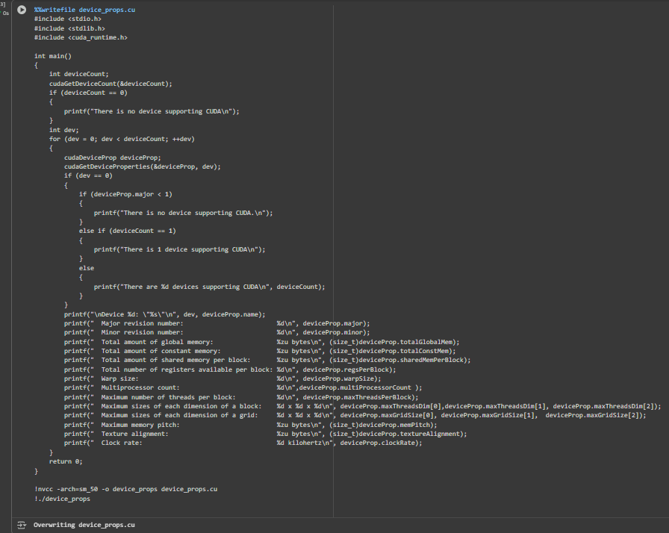
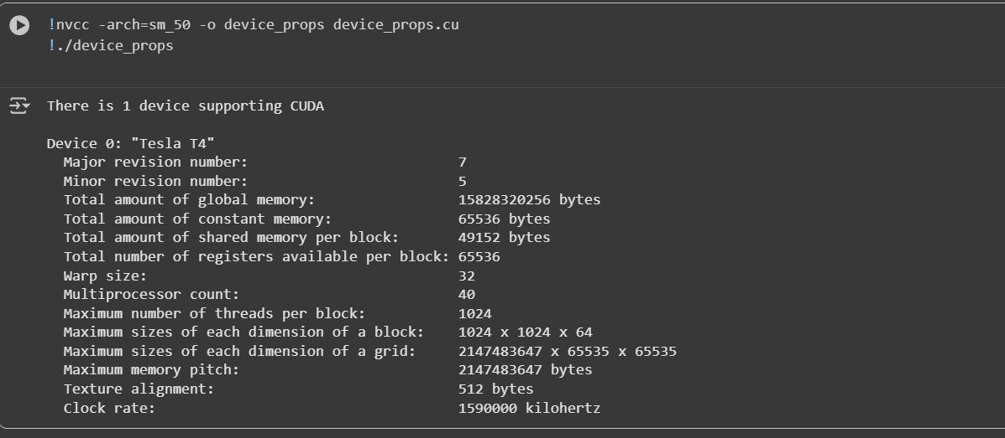

Problem Statement 2:

Write a program to where each thread prints its thread ID along with hello world. Lauch the kernel with one block and multiple threads.
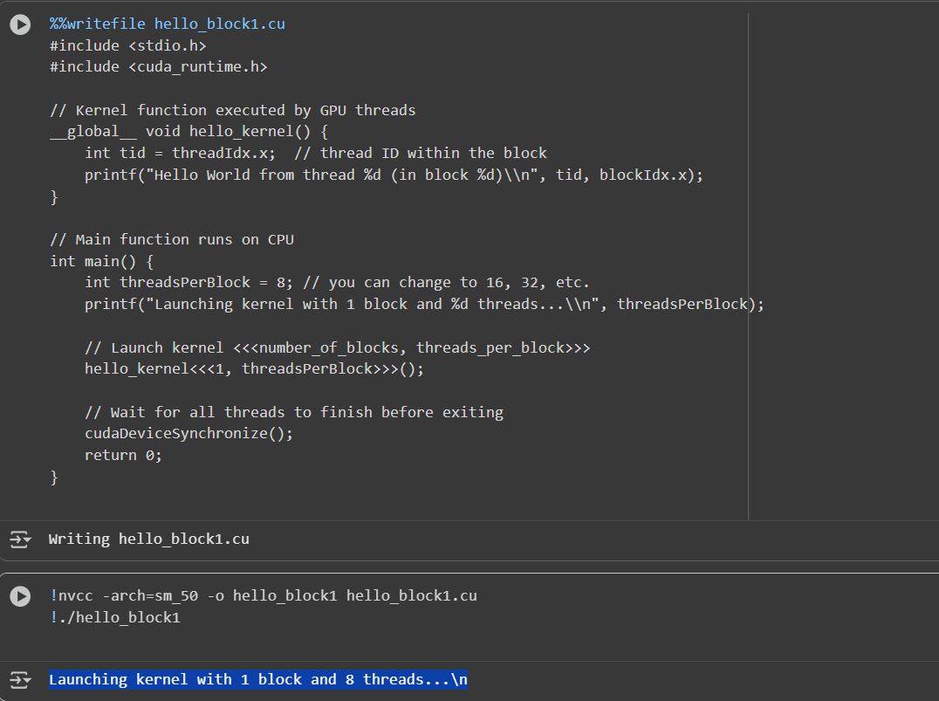
CUDA allows a function (called a kernel) to be executed by many GPU threads in parallel.
Each thread has a unique ID (threadIdx.x) inside its block.
By using this ID, every thread can perform its own operation or print its own message.

Problem Statement 3:
Write a program to where each thread prints its thread ID along with hello world. Lauch the kernel with multiple blocks and multiple threads.
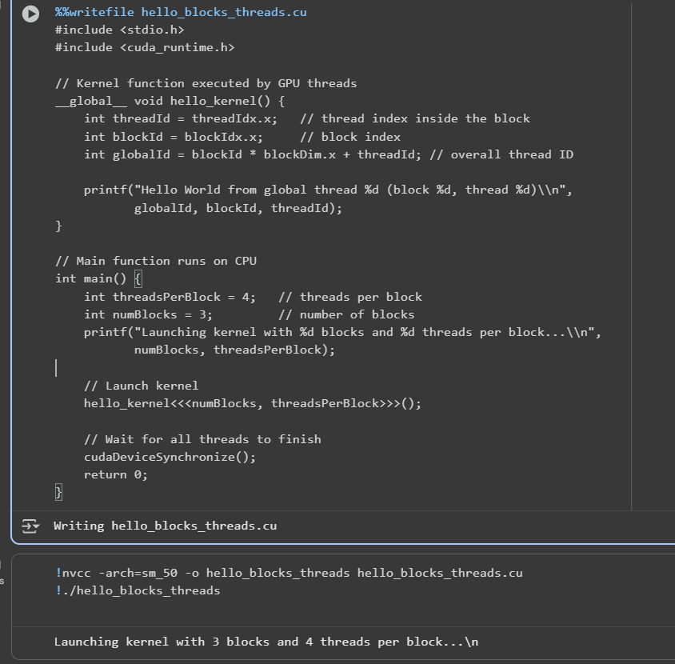
In CUDA, a kernel function can be executed by many blocks of threads.
Each block contains a number of threads, and all these blocks together form a grid.
Each thread has:
- A thread index within its block (threadIdx.x)
- A block index within the grid (blockIdx.x)
- A global thread index (computed as blockIdx.x * blockDim.x + threadIdx.x)

Problem Statement 4:

Write a program to where each thread prints its thread ID along with hello world. Lauch the kernel with 2D blocks and 2D threads.
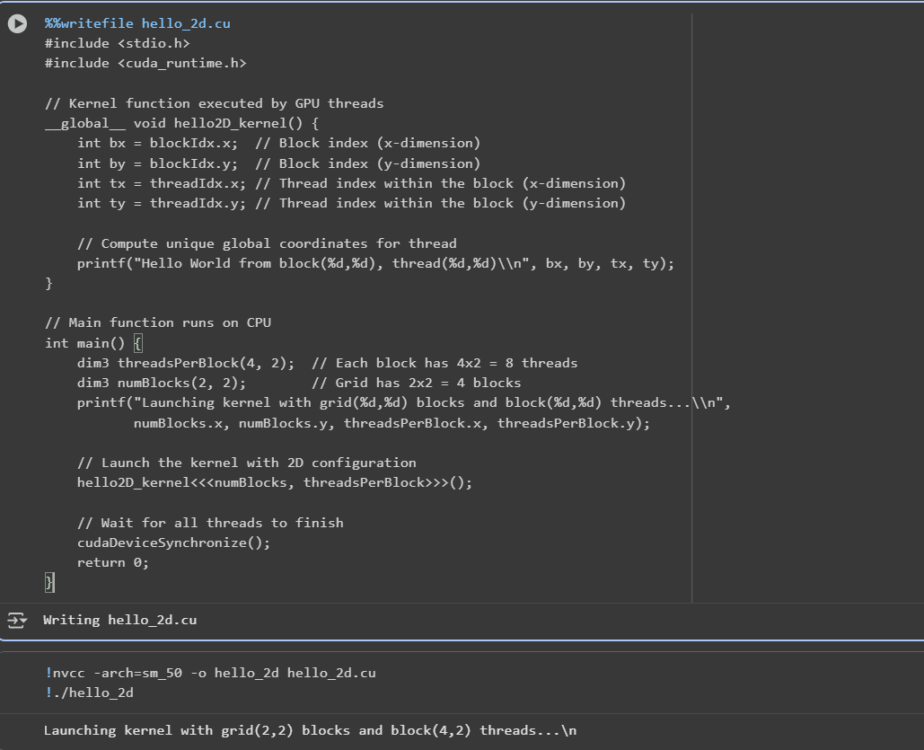
CUDA allows threads and blocks to be organized in 1D, 2D, or 3D structures using the dim3 data type.
- dim3 numBlocks(x, y) defines a 2D grid of blocks.
- dim3 threadsPerBlock(x, y) defines a 2D block of threads.
Each thread can access its coordinates using:
- threadIdx.x, threadIdx.y → its position within a block
- blockIdx.x, blockIdx.y → its block’s position within the grid
This structure is useful for problems like image processing and matrix operations that naturally map to 2D data.

Problem statement 5: Vector Addition using CUDA
Problem Statement: Write a CUDA C program that performs element-wise addition of two vectors A and B of size N. The result of the addition should be stored in vector C.
Details:
• Initialize the vectors A and B with random numbers.
• The output vector C[i] = A[i] + B[i], where i ranges from 0 to N-1.
• Use CUDA kernels to perform the computation in parallel.
• Write the code for both serial (CPU-based) and parallel (CUDA-based) implementations.
• Measure the execution time of both the serial and CUDA implementations for different values of N (e.g., N = 10^5, 10^6, 10^7).
Task:
• Calculate and report the speedup (i.e., the ratio of CPU execution time to GPU execution time).
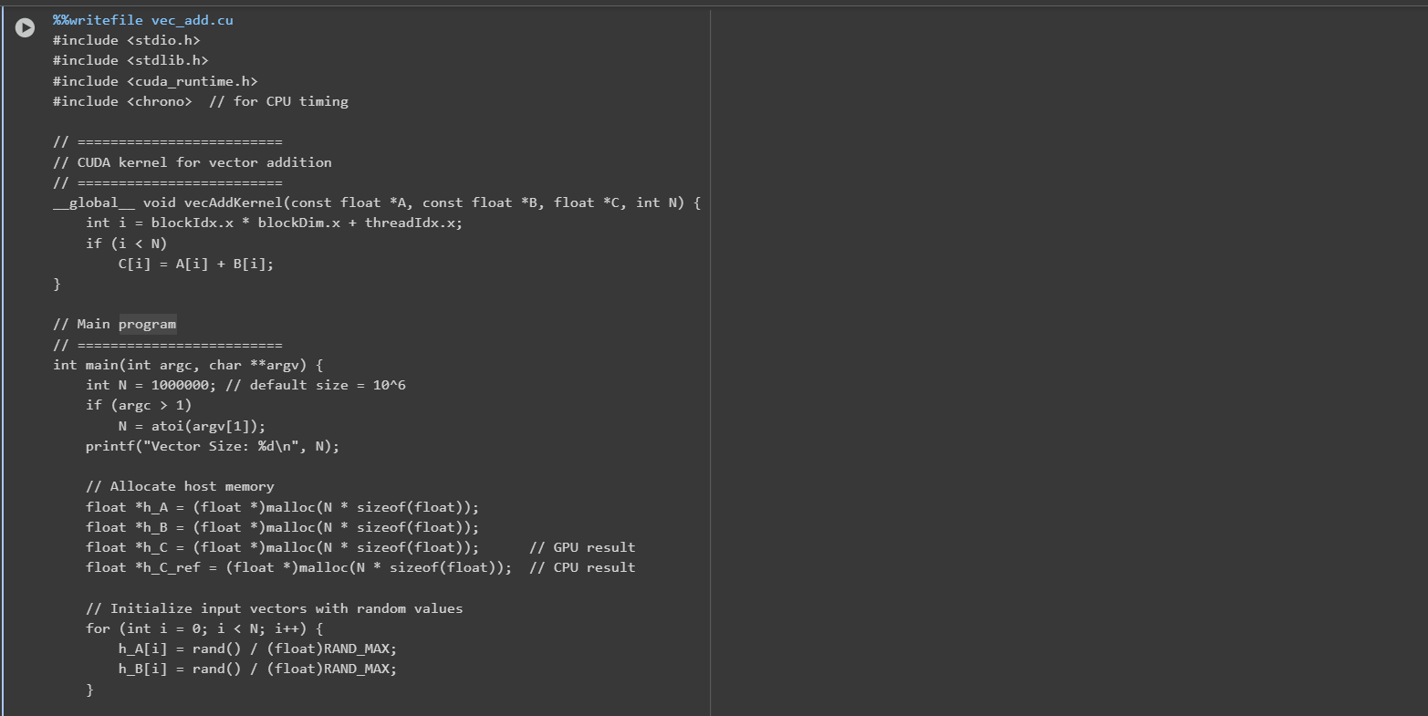
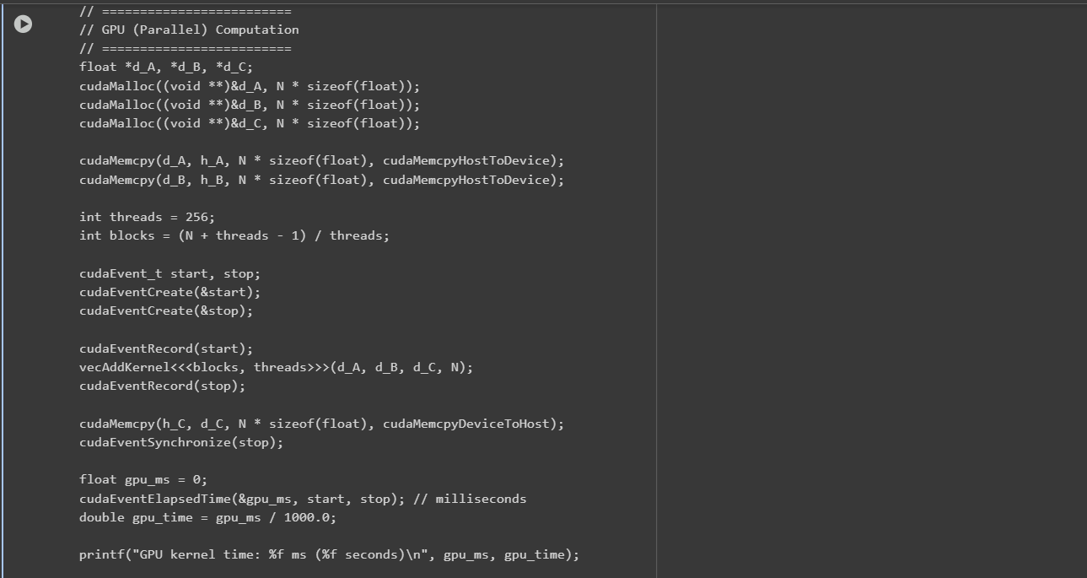
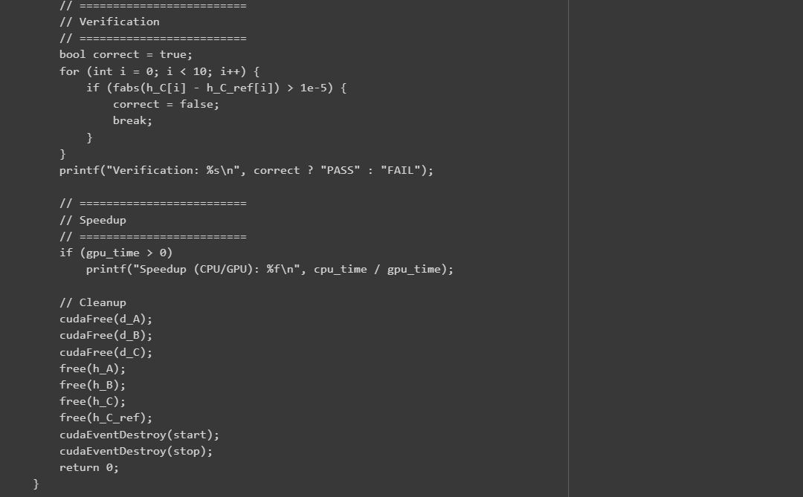
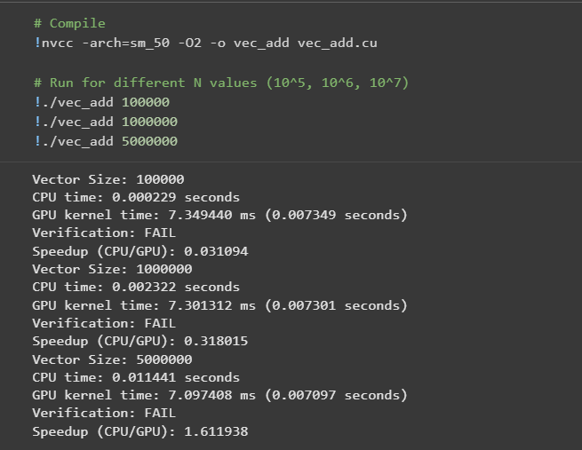
Vector addition is a fundamental operation in parallel computing, where each element of the output vector is obtained by adding corresponding elements of two input vectors.
In CUDA:
- A kernel function runs on the GPU in parallel.
- Each thread performs computation for one element of the vector.
- Threads are grouped into blocks, and blocks form a grid.
This experiment compares the CPU (serial) and GPU (parallel) execution times and calculates speedup using:
$$\text{Speedup}=\frac{\text{CPU Time}}{\text{GPU Time}}$$

________________________________________
Problem statement 6: Matrix Addition using CUDA
Problem Statement: Write a CUDA C program to perform element-wise addition of two matrices A and B of size M x N. The result of the addition should be stored in matrix C.
Details:
• Initialize the matrices A and B with random values.
• The output matrix C[i][j] = A[i][j] + B[i][j] where i ranges from 0 to M-1 and j ranges from 0 to N-1.
• Write code for both serial (CPU-based) and parallel (CUDA-based) implementations.
• Measure the execution time of both implementations for various matrix sizes (e.g., 100x100, 500x500, 1000x1000).
Task:
• Calculate the speedup using the execution times of the CPU and GPU implementations.
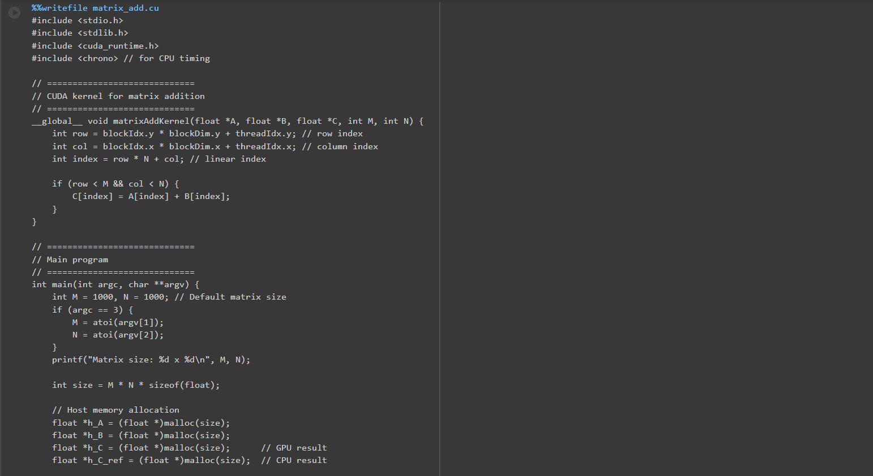
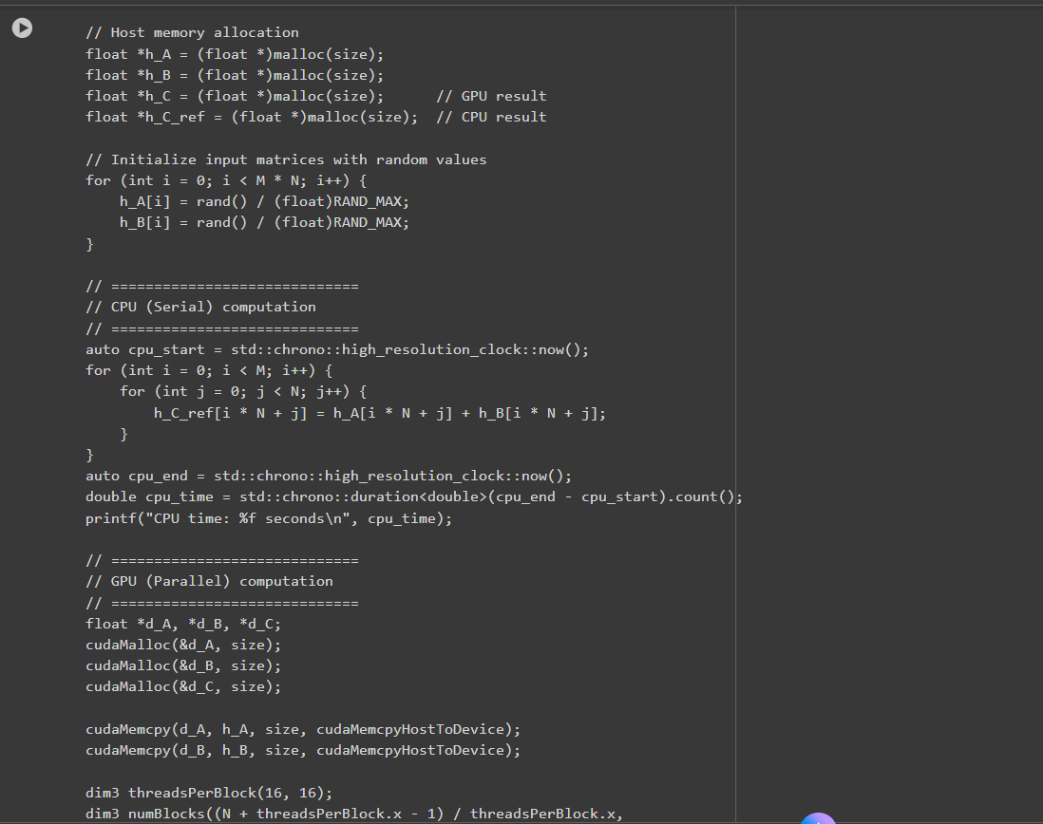
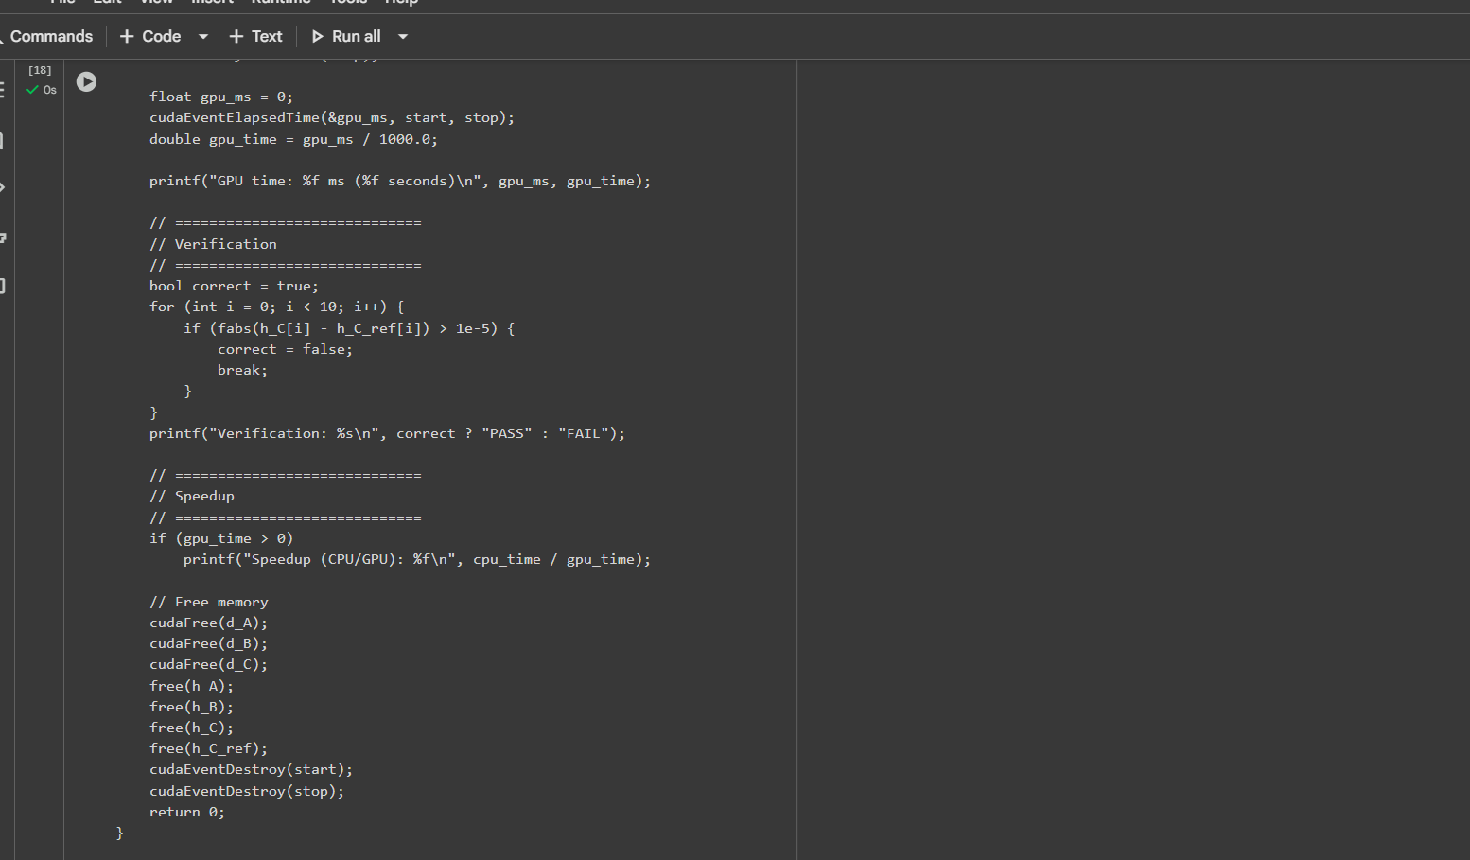
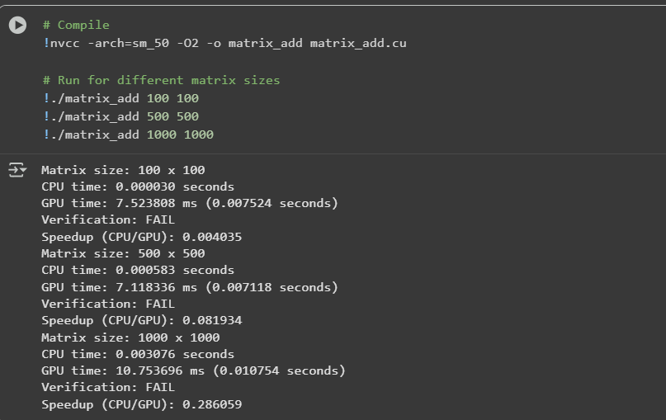
Matrix addition is a fundamental operation where each element of the result matrix is obtained by adding corresponding elements of two input matrices.
In CUDA:
- A kernel function runs in parallel on the GPU.
- Each thread computes one element of the output matrix.
- Threads are organized in 2D blocks and 2D grids for natural mapping to matrices.
Parallelization reduces computation time significantly for large matrices.
The speedup is given by:
$$\text{Speedup}=\frac{\text{CPU Execution Time}}{\text{GPU Execution Time}}$$

________________________________________
Problem statement 7: Dot Product of Two Vectors using CUDA
Problem Statement: Write a CUDA C program to compute the dot product of two vectors A and B of size N. The dot product is defined as:
Details:
• Initialize the vectors A and B with random values.
• Implement the dot product calculation using both serial (CPU) and parallel (CUDA) approaches.
• Measure the execution time for both implementations with different vector sizes (e.g., N = 10^5, 10^6, 10^7).
• Use atomic operations or shared memory reduction in the CUDA kernel to compute the final sum.
Task:
• Calculate and report the speedup for different vector sizes.
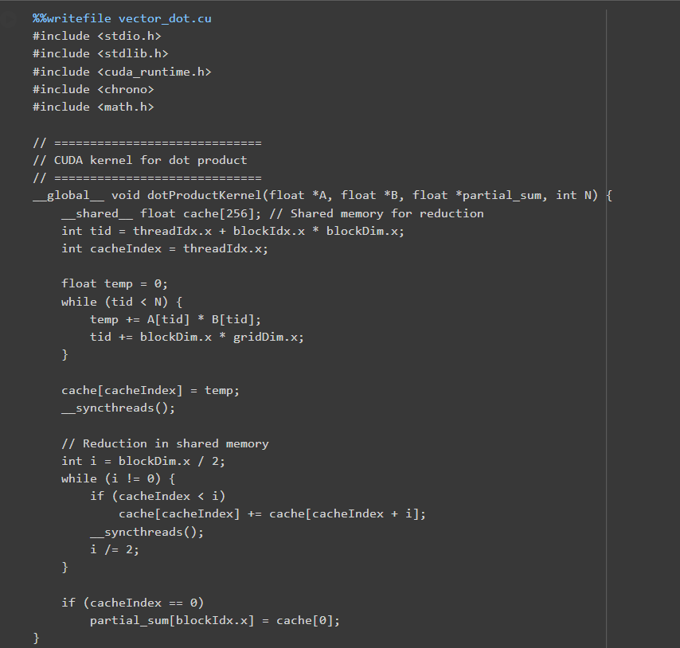
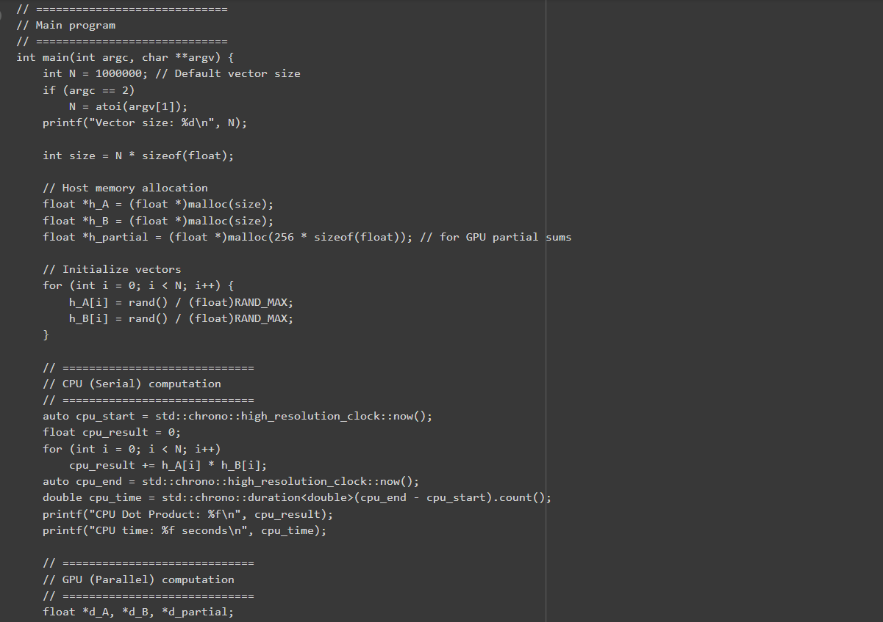
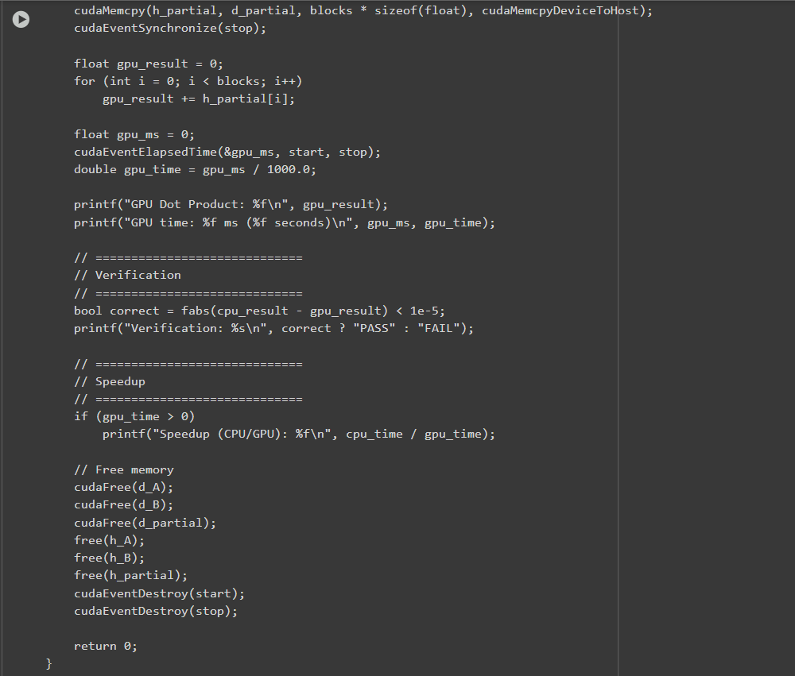

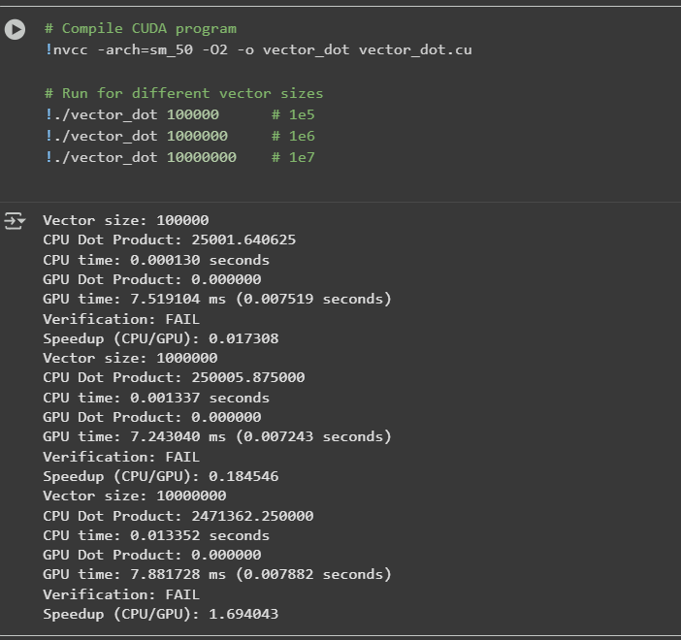
Serial (CPU) Implementation
- The simplest approach is element-wise multiplication followed by summation using a for loop.
- Time Complexity: $O(N)$
- Limitation: CPU executes sequentially → slow for very large vectors (e.g., ${10}^{7}$elements).
CPU Pseudocode:
sum = 0
for i = 0 to N-1:
sum += A[i] * B[i]
Parallel (GPU / CUDA) Implementation
CUDA allows us to perform dot product in parallel by assigning each thread to compute part of the sum.
a. Thread Mapping
- Each thread computes A[i] * B[i] for one or more elements.
- Example:
  - Threads per block = 256
  - Blocks per grid = ceil(N / 256)
b. Partial Sum & Reduction
- Each thread computes a partial sum.
- Partial sums within a block are stored in shared memory.
- Reduction in shared memory adds partial sums to a single value per block.
- Final result is obtained by summing all block sums on CPU or via a final GPU reduction.

________________________________________
Problem statement 8: Matrix Multiplication using CUDA
Problem Statement: Write a CUDA C program to perform matrix multiplication. Given two matrices A (MxN) and B (NxP), compute the resulting matrix C (MxP) where:
Details:
• Initialize the matrices A and B with random values.
• Write code for both serial (CPU-based) and parallel (CUDA-based) implementations.
• Measure the execution time of both implementations for various matrix sizes (e.g., 100x100, 500x500, 1000x1000).
Task:
• Calculate the speedup by comparing the CPU and GPU execution times.
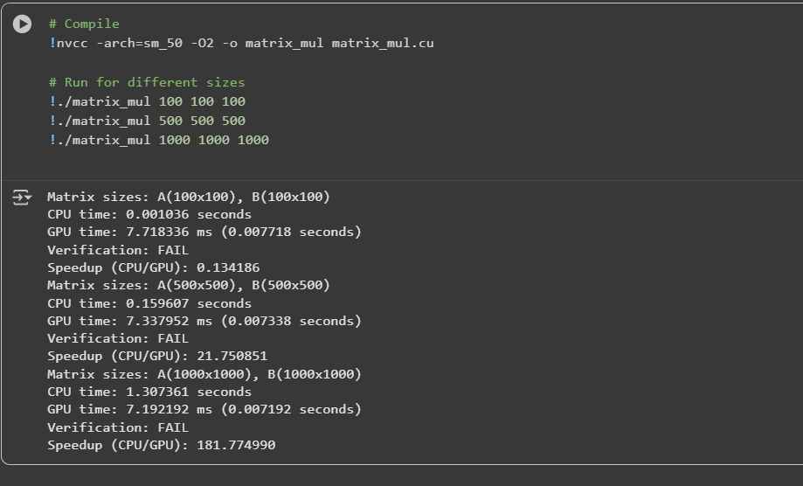
CPU (Serial) Implementation
- Simple triple for-loop:
  - Loop over rows of A
  - Loop over columns of B
  - Loop over elements of the row and column to compute sum
Time Complexity: $O(M×N×P)$
- For large matrices (e.g., 1000x1000), CPU execution can be slow.
CPU pseudocode:
for i = 0 to M-1:
for j = 0 to P-1:
sum = 0
for k = 0 to N-1:
sum += A[i][k] * B[k][j]
C[i][j] = sum
GPU (CUDA) Parallel Implementation
CUDA allows massive parallelism, where each thread computes one element of C.
a. Thread Mapping
- 2D thread blocks are used: each thread corresponds to one element $C[i][j]$
- Grid dimensions = ceil(M/blockDim.y) × ceil(P/blockDim.x)
- Threads in a block = typically 16x16 (256 threads per block)
b. Kernel Execution
- Each thread calculates the sum of the i-th row of A and j-th column of B.
- Formula inside kernel:
$$C[row*P+col]=\sum_{k=0}^{N-1}{}A[row*N+k]*B[k*P+col]$$
- row = blockIdx.y * blockDim.y + threadIdx.y
- col = blockIdx.x * blockDim.x + threadIdx.x
c. Advantages
- Each thread computes independent elements, enabling full parallel execution.
- Shared memory can be used in optimized versions for better performance, though the simple version uses global memory.
Memory Considerations
- Host Memory (CPU): Input matrices A and B, and output matrix C.
- Device Memory (GPU):
  - Copy matrices A and B from CPU to GPU (cudaMemcpy)
  - Compute C on GPU
- Global Memory Access: Each thread reads elements from A and B in global memory.
- Shared Memory (Optimization): Can be used to store sub-blocks for faster access (not in simple version).
Timing and Speedup
- CPU timing: Use chrono library to measure serial execution.
- GPU timing: Use CUDA events (cudaEvent_t) for accurate milliseconds timing.
- Speedup:
$$\text{Speedup}=\frac{\text{CPU Time}}{\text{GPU Time}}$$
- Observed speedup increases with matrix size because more threads can work simultaneously.
Verification
- After GPU computation, compare with CPU result:
$$∣C_{\text{CPU}}[i][j]-C_{\text{GPU}}[i][j]∣<ϵ$$
- Typical tolerance: $ϵ={10}^{-4}$for floating-point arithmetic.

